# CHAPTER 1

### INTRODUCTION

The Rural Out reach Program is designed to uplift rural communities by addressing key issues such as health awareness, environmental sustainability, skill development, and heritage tourism promotion. The program is structured to empower rural populations through education, technology, and sustainable practices while ensuring active community participation. By integrating innovative approaches, research-driven strategies, and professional values, the outreach program has made a significant impact in different domains of rural development.

Plantation and adoption of trees play a crucial role in maintaining ecological balance and combating environmental issues such as deforestation, air pollution, and climate change. Trees act as natural air purifiers by absorbing carbon dioxide and releasing oxygen, making them essential for a healthy environment. Tree plantations help in preventing soil erosion, conserving water, and providing habitat for diverse wildlife. By actively participating in tree planting and adoption programs, individuals contribute to a sustainable future, improving biodiversity and ensuring a cleaner, greener planet for future generations.

The Heritage Walk and Crafts Corner event at Someshwar Temple, Lakshmeshwar, was organized to promote cultural awareness, historical significance, and traditional craftsmanship. The Someshwar Temple, an architectural marvel, holds immense historical and spiritual value, reflecting the rich heritage of Karnataka The Crafts Corner showcased traditional arts and crafts, providing a platform for local artisans to display their skills and preserve age-old craftsmanship. This initiative not only celebrated local heritage but also encouraged community participation in conserving historical sites. The event served as a meaningful experience, blending history, culture, and creativity while inspiring people to engage in heritage conservation and support traditional artisans.

Organic farming is a sustainable agricultural system that focuses on cultivating crops and raising livestock using natural methods, avoiding synthetic fertilizers, pesticides, and genetically modified organisms (GMOs). By relying on organic manure, crop rotation, biological pest control, and natural fertilizers like compost, this method ensures long-term agricultural productivity without harming the ecosystem

Waste management refers to the collection, transportation, processing, recycling, and disposal of waste materials in a way that minimizes their impact on the environment and human health. It is a crucial practice for maintaining cleanliness, conserving resources, and preventing pollution. Effective waste management ensures that waste is properly handled, reducing its negative effects on ecosystems and promoting sustainability.With rapid urbanization, industrialization, and population growth, waste generation has increased significantly. Improper disposal of waste can lead to environmental hazards such as air and water pollution, soil contamination, and the spread of diseases. Waste management involves various strategies, including waste segregation, recycling, composting, and waste-to-energy conversion, to ensure efficient and eco-friendly disposal.

Water conservation refers to the efficient use and management of water resources to prevent wastage and ensure a sustainable supply for future generations. As a vital natural resource, water is essential for drinking, agriculture, industry, and ecosystem balance. However, rapid population growth, urbanization, climate change, and excessive water consumption have led to water scarcity in many regions, making conservation efforts crucial. The primary goal of water conservation is to reduce unnecessary water use, improve efficiency, and protect natural water sources such as rivers, lakes, and groundwater. This can be achieved through various methods, including rainwater harvesting, waste water recycling, efficient irrigation techniques, and public awareness campaigns.

Planting and adopting a cinnamon tree promotes environmental sustainability and biodiversity while offering numerous health and economic benefits. A heritage walk to the historic Someshwar Temple provides a deep cultural and spiritual experience, showcasing the architectural and historical significance of the region. Organic farming in Lakshmeshwar reflects a commitment to sustainable agriculture, ensuring soil health and chemical-free food production. Waste management initiatives in Lakshmeshwar focus on proper disposal, recycling, and reducing environmental pollution, contributing to a cleaner and healthier community. Additionally, water conservation efforts in Lakshmeshwar emphasize efficient water use, rainwater harvesting, and sustainable practices to preserve this vital resource for future generations.

# CHAPTER 2

### ACTIVITY-1: Plantation And Adoption of Tree

* 1. **Overview**

Tree plantation and adoption are vital initiatives for environmental conservation, climate change mitigation, and biodiversity enhancement. Plantation involves the systematic planting of trees to restore green cover, combat deforestation, and improve air quality. Trees play a crucial role in absorbing carbon dioxide, releasing oxygen, preventing soil erosion, and supporting wildlife habitats. Tree adoption goes beyond planting by ensuring the long-term care and maintenance of trees. When individuals, communities, or organizations adopt a tree, they commit to nurturing it by providing water, protecting it from pests, and ensuring its healthy growth. This practice fosters a sense of responsibility toward nature and promotes sustainable environmental stewardship. Engaging in tree plantation and adoption benefits both urban and rural areas. In cities, trees provide shade, reduce heat, and improve air quality, while in rural areas, they support agriculture, prevent desertification, and enhance biodiversity. Through collective efforts, tree plantation and adoption contribute significantly to creating a greener and healthier planet for future generations.

Cinnamon is an evergreen tree characterized by oval-shaped leaves, thick bark and a berry fruit. When harvesting the spice, the bark and leaves are the primary parts of the plant used. Cinnamon is cultivated by growing the tree for two years, then coppicing it, i.e., cutting the stems at ground level. The following year, about a dozen new shoots form from the roots, replacing those that were cut. A less than ideal drying environment encourages the proliferation of pests in the bark, which may then require treatment by fumigation with sulphur dioxide. In 2011, the European Union approved the use of sulphur dioxide at a concentration of up to 150 mg/kg (0.0024 oz/lb.) for the treatment of C. verum bark harvested in Sri Lanka. The flavour of cinnamon is due to an aromatic essential oil that makes up 0.5 to 1% of its composition. This essential oil can be prepared by roughly pounding the bark, macerating it in sea water, and then quickly distilling the whole. It is of a golden yellow colour, with the characteristic odour of cinnamon and a very hot aromatic taste. The pungent taste and scent come from cinnamaldehyde (about 90% of the essential oil from the bark) and, by reaction with oxygen as it ages, it darkens in colour and forms resinous compounds. Cinnamon constituents include some 80 aromatic compounds, including eugenol, found in the oil from leaves or bark of cinnamon trees.

### Use of Technology

Technology plays a crucial role in enhancing tree plantation and adoption efforts, making them more efficient, sustainable, and impactful. Various technological advancements have been integrated into afforestation programs, allowing better monitoring, data collection, and maintenance of trees.

#### GIS and Remote Sensing

Geographic Information Systems (GIS) and satellite remote sensing help identify deforested areas, monitor tree growth, and track plantation progress. These technologies provide real-time data on forest cover and help in planning large-scale afforestation projects.

#### Drones for Plantation and Monitoring

Drones are used to plant tree seeds in areas that are difficult to reach, such as mountains and deserts. They also help in monitoring tree health, detecting diseases, and assessing environmental conditions.

#### Mobile Applications for Tree Adoption

Several mobile apps allow individuals and organizations to adopt trees, track their growth, and receive updates. These apps also provide information on tree species, ideal plantation conditions, and best maintenance practices.

#### IoT-Based Smart Irrigation

Internet of Things (IoT) devices help optimize water usage for tree plantations by monitoring soil moisture levels and automating irrigation. This prevents water wastage and ensures trees receive adequate hydration.

#### AI and Big Data Analytics

Artificial Intelligence (AI) and big data are used to analyze climate patterns, predict the best plantation areas, and recommend suitable tree species. AI-powered tools also assist in early detection of diseases and pest infestations.

Technology has significantly transformed the way plantations are managed, and the adoption of crops like cinnamon trees can benefit from these advancements. Here's how technology can be used in plantation management, especially in adopting and growing cinnamon trees:

#### Precision Agriculture

* **Remote Sensing and Drones**: Drones and satellite imagery can help monitor large plantations, tracking plant health, soil conditions, and weather patterns. For cinnamon, this could allow farmers to identify areas of the plantation that need attention, whether for irrigation, pest control, or soil improvement.
* **Soil and Water Sensors**: These sensors help monitor soil moisture, pH levels, and nutrient content, enabling precise irrigation and fertilization, which can improve cinnamon tree growth and yield.

#### Automation and Robotics

* **Planting and Harvesting**: Mechanized planters and harvesters can be used for crops like cinnamon, reducing labor costs and increasing efficiency. Harvesting cinnamon, which requires peeling the bark, can be optimized with specialized machines, improving precision and reducing damage to the trees.
* **Weeding and Pest Control**: Robots and automated systems can be used for weeding, fertilization, and pest control, minimizing the use of harmful chemicals and ensuring healthy cinnamon plants.

#### Genetics and Biotechnology

* **Disease-resistant Cinnamon Trees**: By using genetic engineering or selective breeding, scientists can develop cinnamon trees that are more resistant to pests and diseases. This is crucial for maintaining a healthy plantation and ensuring consistent cinnamon production.
* **Improved Varieties**: Biotechnology can also be used to produce cinnamon varieties that grow faster, yield more, or have better resistance to environmental stress.

#### Data Analytics and Artificial Intelligence (AI)

* **Predictive Analytics**: Using AI to analyze weather patterns, market trends, and historical data, farmers can make informed decisions about when to plant, irrigate, and harvest their cinnamon trees.
* **Crop Health Monitoring**: AI algorithms can detect early signs of disease or pest infestations by analyzing images from drones or ground-based cameras. Early intervention can prevent widespread damage to the plantation.

### Sustainable Development best practices

Sustainable tree plantation and adoption are crucial for maintaining ecological balance, combating climate change, and promoting environmental stewardship. To ensure long-term success, selecting appropriate planting sites based on soil quality, climate conditions, and water availability is essential. Native and drought-resistant tree species should be prioritized as they are well-adapted to local conditions, require minimal maintenance, and support regional biodiversity. Community engagement is a fundamental aspect of sustainable tree plantation, as active participation from local residents, schools, non-governmental organizations (NGOs), and businesses fosters a sense of responsibility and ensures ongoing care.

Awareness programs, workshops, and environmental education campaigns help people understand the importance of trees in air purification, carbon sequestration, and mitigating climate change effects. Smart irrigation techniques, such as drip irrigation, rainwater harvesting, and IoT-based moisture monitoring systems, optimize water usage, ensuring efficient tree growth while conserving valuable water resources. Additionally, post-plantation care is crucial, and tree adoption programs encourage individuals, communities, and corporations to take ownership of planted trees, ensuring their proper nurturing, protection, and long-term survival.

To establish sustainable and best practices for the plantation and adoption of cinnamon trees at SKSVMACET in Lakshmeshwar, the approach should focus on environmental sustainability, agricultural best practices, and community involvement. Below are key strategies to ensure the successful adoption of cinnamon trees in the college's agricultural projects:

#### Soil Health Management

* **Soil Testing**: Conduct soil tests to determine the pH, nutrient levels, and organic matter content of the land. Cinnamon trees thrive in slightly acidic soil (pH 5.5-6.5), so adjusting soil conditions accordingly will help optimize growth.
* **Organic Fertilizers**: Use organic fertilizers like compost, farmyard manure, or vermicompost to enrich the soil. This reduces the dependency on chemical fertilizers, improving soil fertility and maintaining sustainability.
* **Cover Crops and Mulching**: Grow cover crops (like legumes) around the cinnamon trees to prevent soil erosion, maintain soil moisture, and improve nitrogen levels. Mulching can help retain moisture, regulate temperature, and suppress weed growth.

#### Water Conservation and Efficient Irrigation

* **Drip Irrigation**: Implement a drip irrigation system to efficiently deliver water directly to the roots, reducing water wastage and ensuring that the cinnamon trees receive consistent moisture.
* **Rainwater Harvesting**: Set up a rainwater harvesting system to collect and store rainwater, which can be used for irrigation. This reduces the dependence on groundwater and promotes water conservation.
* **Water Monitoring**: Use soil moisture sensors to monitor the water needs of the cinnamon trees and adjust irrigation schedules accordingly.

#### Agro forestry and Biodiversity Integration

* **Agro forestry Practices**: Integrate cinnamon cultivation with other trees or crops in an agroforestry system to promote biodiversity. This can also help improve soil structure, increase organic matter, and provide additional sources of income.
* **Native Planting**: Include native plants and trees in the plantation to preserve the local biodiversity and create a habitat for beneficial insects and wildlife, fostering an ecosystem that supports cinnamon tree growth.

By incorporating these sustainable practices and leveraging technology, SKSVMACET in Lakshmeshwar can successfully adopt cinnamon cultivation while also promoting environmental sustainability, enhancing local agriculture, and providing valuable educational opportunities for students. The focus on sustainable water usage, soil health, pest management, and community involvement will ensure that the cinnamon plantation thrives while contributing positively to the local ecosystem and economy.

### ACTIVITY-2: Heritage Walk and Crafts Corner

* 1. **Overview**

As part of an AICTE activity, we actively participated in a Heritage Walk and a Crafts Corner at the historic Someshwara Temple in Lakshmeshwara, an experience that offered deep insights into the region’s rich cultural and architectural heritage. The Heritage Walk provided an opportunity to explore the grandeur of the Chalukyan-era temple, renowned for its intricate carvings, ancient inscriptions, and unique blend of Dravidian and Nagara architectural styles. Through guided interactions, we learned about the temple’s historical significance, its role in local traditions, and the artistic excellence of the time.

In addition to the Heritage Walk, the Crafts Corner showcased the region’s traditional craftsmanship, including stone carvings, woodwork, handloom textiles, and pottery. Local artisans demonstrated their skills, providing a glimpse into the centuries-old techniques used in crafting temple sculptures, decorative items, and daily-use artifacts. This initiative not only celebrated the artistry of Lakshmeshwara but also emphasized the importance of preserving and promoting indigenous crafts.

The event fostered a deep appreciation for history, architecture, and traditional art forms while encouraging sustainable heritage conservation. It also highlighted the cultural and economic impact of heritage tourism and local craftsmanship. Participating in this AICTE activity was an enriching experience, strengthening our connection with India’s historical and artistic legacy while inspiring efforts to safeguard such invaluable traditions for future generations.

Overview of Heritage Walk and Crafts Corner A Heritage Walk is an immersive experience that allows participants to explore and understand the historical, cultural, and architectural significance of a place. It is designed to showcase ancient monuments, temples, forts, traditional markets, and other heritage sites, helping to preserve and promote local history. Heritage walks provide an opportunity to learn about the historical events, architectural styles, and socio-cultural aspects that shaped a particular region.

### Use of Technology

The use of technology in heritage walks and crafts corners has revolutionized the way we experience, preserve, and promote cultural heritage. Augmented Reality (AR) and Virtual Reality (VR) have enabled immersive experiences, allowing visitors to visualize historical sites in their original grandeur, even if they are in ruins today. Mobile applications and GPS-based digital guides provide real-time information, interactive maps, and storytelling elements that enhance the learning experience during heritage walks. Drones and 3D scanning technology are being used to document and digitally reconstruct heritage sites, ensuring accurate preservation and restoration. In crafts corners, technology has played a crucial role in preserving traditional craftsmanship. E-commerce platforms and social media have given artisans global exposure, helping them sell handmade products and sustain their livelihoods. AI-powered design tools assist artisans in innovating while retaining traditional aesthetics. Additionally, blockchain technology is being explored to authenticate and certify handmade crafts, preventing duplication and ensuring fair trade. By integrating modern technology with heritage conservation and traditional craftsmanship, these initiatives help bridge the gap between history and the digital age, making cultural heritage more accessible, engaging, and sustainable for future generations.

Using technology in a heritage walk to the Someshwar Temple in Lakshmeshwar can significantly enhance the visitor experience by providing deeper insights, improving accessibility, and ensuring the conservation of the site. Here's how technology can be integrated into the heritage walk:

#### Augmented Reality (AR) for Interactive Experiences

* **Historical Overlay**: Visitors can use smartphones or AR glasses to view historical overlays of the Someshwar Temple. For instance, while walking around the temple, they could see what it looked like in its prime or how it has evolved over the centuries.
* **Virtual Reconstructions**: Provide a virtual tour that reconstructs parts of the temple and surrounding areas, allowing visitors to explore sections that may not be physically accessible or are under renovation.

#### Mobile Apps for Guided Tours

* **Audio Guides**: Develop a mobile app or integrate with existing platforms (like Google Maps or specific heritage walk apps) to offer audio-guided tours. The app can provide detailed explanations about the temple's history, architecture, and significance at different points during the walk.
* **Multi-language Support**: The app can have multi-language support, allowing visitors from various regions to learn about the temple in their native language.

#### Geolocation and GPS for Navigation

* **Interactive Maps**: Create interactive GPS-enabled maps that guide visitors to key locations within the temple complex and surrounding areas, providing contextual information about each spot.
* **Pathway Optimization**: GPS tracking can help create an optimized route for the heritage walk, ensuring that visitors can explore the temple and its surroundings in an efficient and informative way.

#### QR Codes for On-Site Information

* **QR Code Scanning**: Place QR codes near important parts of the temple, sculptures, or historical markers. When scanned, these codes can provide detailed information, videos, or images related to that specific location or artifact. This allows for a self-paced, personalized tour.
* **3D Visuals of Artifacts**: Use QR codes to link to 3D visuals of artifacts, allowing visitors to view ancient items or sculptures in greater detail.

#### Virtual Reality (VR) for Immersive Experiences

* **Virtual Temple Tours**: For visitors who cannot physically visit the temple, create VR experiences that allow them to virtually walk through the Someshwar Temple, exploring its architecture, history, and surroundings from anywhere in the world.
* **Immersive History**: Provide immersive VR experiences where users can witness historical events related to the temple, such as its construction, religious rituals, or cultural festivals.

Incorporating these technological innovations in the heritage walk to the Someshwar Temple can create an engaging, educational, and interactive experience for visitors. It will not only enhance the tourism experience but also contribute to the preservation of the temple’s cultural and historical value for future generations. By using technology to bridge the gap between the past and present, visitors can develop a deeper connection to the temple and its significance.

### 2.2 Sustainable Development Best Practices

Sustainable development practices for heritage walks, such as the one to Someshwar Temple in Lakshmeshar, involve preserving both the natural environment and cultural heritage while ensuring that the needs of local communities and tourists are met without compromising the ability of future generations to benefit from these resources.

Here are some key sustainable development practices that can be applied to a heritage walk to Someshwar Temple:

#### Cultural Preservation

* **Protecting the Heritage Site**: The Someshwar Temple, being a historical and cultural site, should be maintained and protected from physical degradation due to tourism. Regular restoration work using traditional methods and locally sourced materials can preserve the temple’s architectural integrity.
* **Community Involvement**: Local communities should be actively involved in the preservation efforts. This includes educating locals and visitors about the significance of the site and encouraging them to follow sustainable practices while visiting.

#### Eco-friendly Tourism

* **Low Impact Trails**: The heritage walk to the temple should be designed to minimize environmental degradation. Pathways should be well-marked and constructed using eco-friendly materials, and visitors should be encouraged to stay on designated trails to avoid damaging local vegetation and wildlife.
* **Waste Management**: Proper waste disposal facilities should be provided along the walk, including recycling bins and composting facilities, to ensure that littering is minimized. Educational signs about waste reduction can be placed to promote responsible visitor behavior.
* **Carbon Footprint Reduction**: Encourage the use of eco-friendly transportation options such as walking, cycling, or carpooling to reduce carbon emissions associated with travel to the heritage site.

#### Education and Awareness

* **Informational Signage**: Install informational boards along the walk that highlight the cultural significance of the Someshwar Temple, the history of Lakshmeshar, and the need for preservation. These signs can also include tips on how to engage in sustainable tourism practices.
* **Local Guides and Training**: Train local guides to provide informative tours that emphasize the importance of sustainable practices and educate visitors about the site’s history, local traditions, and the ecology of the region.

By integrating these sustainable development practices, the heritage walk to Someshwar Temple can contribute to the preservation of the cultural and environmental integrity of the region, while also supporting local communities economically and socially. This holistic approach ensures that both heritage and the surrounding natural environment are protected for future generations to enjoy.

### ACTIVITY-3: Organic Farming

* 1. **Overview**

Organic farming is a sustainable agricultural practice that emphasizes natural processes, ecological balance, and biodiversity. It avoids synthetic fertilizers, pesticides, genetically modified organisms (GMOs), and artificial additives. Instead, it relies on organic fertilizers like compost and manure, crop rotation, biological pest control, and other natural techniques to maintain soil fertility and protect crops. By working with nature rather than against it, organic farming promotes a healthier and more resilient agricultural system.

One of the key benefits of organic farming is its positive impact on the environment. Since it avoids harmful chemicals, it helps reduce soil and water pollution while preserving beneficial organisms such as earthworms and pollinators. Organic farming also enhances soil health by improving its organic matter content and microbial activity, which leads to better water retention and reduced soil erosion. Additionally, it supports biodiversity by creating a balanced ecosystem where different species coexist naturally.

Beyond environmental benefits, organic farming contributes to human health by producing chemical- free, nutrient-rich food. Studies suggest that organic crops may contain higher levels of vitamins, antioxidants, and essential minerals compared to conventionally grown produce. Organic livestock farming also prohibits the use of antibiotics and synthetic hormones, ensuring healthier meat, dairy, and eggs. This makes organic food an appealing choice for consumers who prioritize health and wellness.

Despite its advantages, organic farming comes with certain challenges. It is often more labor- intensive and costly due to the need for manual weeding, organic fertilizers, and sustainable farming techniques. Organic farmers may also experience lower yields compared to conventional farming, making it harder to meet growing food demands. Additionally, obtaining organic certification can be complex and expensive, requiring strict adherence to regulations.

Despite these challenges, organic farming continues to grow in popularity as consumers become more aware of its benefits. Governments and organizations are increasingly supporting organic practices through incentives, subsidies, and research initiatives. As a result, organic farming is playing a crucial role in shaping a more sustainable and environmentally friendly future for agriculture.

Organic farming in Lakshmeshwar, a town in Karnataka, is part of the state's growing movement toward sustainable agriculture. While detailed information about specific organic farms in Lakshmeshwar is limited, Karnataka as a whole has embraced organic farming, with over 600 organic farms across the state. The town is also home to "Laxmeshwar Dairy Farming," which, while primarily focused on dairy production, may incorporate organic practices. Additionally, students from SKSVMACET have visited local farms to learn about sustainable agricultural methods, including organic farming. As awareness and demand for chemical-free produce increase, organic farming in Lakshmeshwar is likely to expand, contributing to a healthier environment and food system.

### 3.1 Use of Technology

Technology has significantly enhanced organic farming, making it more efficient, sustainable, and scalable. Here's a brief overview of how technology is being used in organic farming:

#### Precision Agriculture

* **Sensors and IoT (Internet of Things)**: These are used to monitor soil health, moisture levels, and nutrient content in real time, helping farmers optimize water and nutrient use without relying on chemical fertilizers.
* **Drones**: Drones are used for aerial surveys, crop monitoring, and assessing plant health. They can quickly identify areas that need attention, helping farmers target interventions more precisely.

#### Automation and Robotics

* **Weed Control Robots**: Robots like the "Naïo Technologies" or "Ecorobotix" are designed to remove weeds mechanically without chemicals, reducing the need for manual labor and enhancing weed management in organic farms.
* **Automated Harvesting Systems**: These systems help with picking fruits and vegetables more efficiently, reducing labor costs and increasing harvesting precision.

#### Data Analytics and Artificial Intelligence (AI)

* **Farm Management Software**: AI-powered software tools help farmers analyze weather patterns, soil conditions, and crop performance to make informed decisions regarding irrigation, planting, and harvesting.
* **Predictive Analytics**: Machine learning algorithms predict pest outbreaks, disease risks, and optimal planting times, helping farmers reduce crop losses without chemical treatments.

#### Sustainable Water Management

* **Drip Irrigation Systems**: Automated drip irrigation systems equipped with sensors can efficiently water crops, conserving water by applying it only when necessary.
* **Rainwater Harvesting**: Technology allows for better storage and management of rainwater, reducing dependency on external water sources.

#### Biotechnology for Organic Pest Management

* **Bio-pesticides**: While organic farming avoids synthetic chemicals, biotechnology has introduced bio- based pest control solutions (like neem oil, pheromone traps, and microbial pest control agents), which are environmentally friendly and effective.
* **Beneficial Insects and Predators**: Technologies are being developed to introduce natural predators (like ladybugs) in a more controlled and efficient manner for organic pest control.

#### Soil Health Monitoring

* **Soil Sensors**: Advanced soil sensors help monitor soil pH, moisture levels, temperature, and nutrient content. This helps farmers apply organic amendments (like compost or manure) in the right amounts to maintain soil fertility.
* **Soil Microbial Analysis**: New technologies are available to analyze soil microbes, which are crucial for organic farming, ensuring healthy, balanced soil ecosystems.

#### Blockchain for Traceability

* **Supply Chain Transparency**: Blockchain technology is used to trace the journey of organic products from farm to market, ensuring transparency and credibility in certification, allowing consumers to trust that the products are truly organic.

#### Crop Monitoring and Remote Sensing

* **Satellite Imagery and Remote Sensing**: These technologies allow farmers to monitor large-scale crops, assessing health and identifying areas requiring attention, helping them manage farms more effectively.

By integrating these technologies, organic farming can become more productive, cost-effective, and sustainable, meeting the growing demand for organic produce while maintaining environmental stewardship.

### 3.3 Sustainable Development Best Practices

Sustainable development best practices in organic farming aim to promote environmental health, economic viability, and social equity. Here are key sustainable practices:

#### Soil Health Management

* **Crop Rotation**: Rotating crops to prevent soil depletion, reduce pest buildup, and improve soil structure. It helps maintain biodiversity and the health of the soil ecosystem.
* **Composting**: Using organic waste like plant residues, manure, and food scraps to create nutrient-rich compost that improves soil fertility, enhances moisture retention, and supports beneficial microbes.
* **Cover Cropping**: Growing specific crops (like clover or legumes) during the off-season to protect soil from erosion, fix nitrogen, and suppress weeds.

#### Biodiversity Promotion

* **Polyculture and Agroforestry**: Growing a variety of crops together (polyculture) or integrating trees with crops (agroforestry) to promote biodiversity. This practice enhances ecosystem resilience, attracts beneficial insects, and improves soil health.
* **Wildlife Habitat Creation**: Leaving areas of natural habitat within or around farms, such as hedgerows or wildlife corridors, to support beneficial insects, birds, and other wildlife.
* **Beneficial Insects**: Encouraging the presence of beneficial insects like ladybugs, bees, and predatory beetles for natural pest control.

#### Water Conservation

* **Drip Irrigation**: Implementing efficient irrigation systems, such as drip irrigation, to minimize water waste and provide water directly to plant roots, reducing evaporation.
* **Rainwater Harvesting**: Collecting and storing rainwater for irrigation reduces the reliance on external water sources, conserving freshwater resources.
* **Soil Moisture Management**: Using techniques like mulching and soil moisture sensors to reduce water evaporation and maintain optimal moisture levels in the soil.

The best practices of sustainable organic farming aim to maintain the balance between food production, environmental health, and social equity. These practices not only contribute to ecological sustainability but also enhance farm profitability, foster community well-being, and help mitigate climate change. By adopting these methods, farmers can ensure that organic farming remains a viable and sustainable solution for future generations.

## ACTIVITY–4: Waste Management.

### Overview

Waste management is the systematic process of handling waste from its creation to its final disposal in an environmentally responsible way. The aim is to minimize waste generation, promote recycling and reuse, and ensure the safe disposal of residual waste. As global populations rise and urban areas expand, the amount of waste produced continues to grow, leading to environmental, economic, and health-related concerns. Effective waste management is essential to reduce pollution, conserve resources, and maintain a clean, healthy environment. With the increasing volume and complexity of waste generated, sustainable waste management practices have become more crucial in the modern world.

A key framework in waste management is the **waste hierarchy**, which prioritizes practices that prevent waste and minimize environmental impact. The hierarchy is structured as follows: **prevention**, which aims to stop waste generation before it occurs; **reduction**, which focuses on decreasing the volume of waste generated through improved design, efficiency, or behavior; **reuse**, encouraging the repurposing of products and materials; **recycling**, converting waste into reusable materials; **energy recovery**, where waste is used to generate energy; and **disposal**, the last resort when other options are not viable. This hierarchical approach helps in making the waste management process more sustainable by focusing on waste reduction and resource conservation first.

Waste can be categorized into various types, each requiring specific treatment and disposal methods. **Municipal solid waste (MSW)** is the most common, encompassing everyday items like food scraps, paper, plastics, and glass. **Industrial waste** includes byproducts of manufacturing, such as chemicals, metals, and oils. **Hazardous waste** refers to materials that are dangerous to human health or the environment, including chemicals, medical waste, and batteries. **Electronic waste (e-waste)** involves discarded electronic devices that may contain harmful substances like lead and mercury and require special handling. Finally, **organic waste**, such as food scraps and plant matter, can be composted and recycled to return nutrients to the soil. Each waste type requires different strategies for treatment, recycling, or safe disposal.

Proper waste management provides several significant benefits to the environment, society, and economy. Environmentally, effective waste management reduces pollution by ensuring that waste does not end up in landfills, oceans, or rivers. Recycling and reusing materials conserve natural resources and reduce the environmental impact of extracting raw materials. Economically, waste management can save money by reducing disposal fees and creating new jobs in waste collection, recycling, and processing industries. Socially, efficient waste management systems help maintain public health by minimizing waste-related hazards, ensuring clean and hygienic surroundings, and improving the quality of life in communities.

Despite its benefits, waste management faces several challenges. One of the major obstacles is the rising volume of waste, driven by increased consumerism, population growth, and urbanization. Many cities, especially in developing countries, struggle with inadequate waste management infrastructure, leading to improper disposal practices such as illegal dumping or burning of waste. Additionally, public awareness and participation in recycling and waste reduction efforts are often limited, hindering the effectiveness of waste management programs. Another challenge is the complexity of managing hazardous waste, e-waste, and other specialized waste types, which require particular expertise and technologies for safe disposal or recycling.

### Use Of Technology

The use of technology in waste management has revolutionized how municipalities, like Lakshmeshwar, address waste disposal and recycling. As urban populations grow and waste generation increases, traditional waste management practices alone are often insufficient. Technology provides effective solutions to improve efficiency, reduce waste, enhance recycling rates, and ensure that waste is disposed of in an environmentally sustainable manner. In Lakshmeshwar, technology adoption can help streamline operations and create a cleaner, more sustainable environment for the residents.

#### Smart Waste Collection Systems

One of the most significant technological advancements in waste management is the introduction of **smart waste collection systems**. These systems utilize **sensors** placed in waste bins or collection points that monitor the fill levels of containers in real time.

These sensors alert waste management teams when bins are full and need to be emptied, allowing for more efficient and timely waste collection. In a municipality like Lakshmeshwar, where resources may be limited, this technology reduces unnecessary trips and optimizes the use of waste collection trucks, reducing fuel consumption and carbon emissions.

#### Waste Segregation Technologies

Technology is playing a key role in improving **waste segregation**, which is crucial for recycling and reducing the amount of waste that ends up in landfills. Automated systems, such as **smart bins** equipped with RFID technology, can help residents and waste collectors sort waste into categories like recyclables, compostables, and non-recyclables. In Lakshmeshwar, municipal waste collection teams could benefit from automated sorting systems at waste processing centers, where machinery can separate waste more efficiently than manual labor, thus improving recycling rates and ensuring that recyclable materials are not wasted.

#### Data Analytics and Waste Monitoring

Data analytics is increasingly being used to enhance waste management practices. In Lakshmeshwar, the use of **data-driven decision-making tools** can help waste management authorities track waste generation patterns, optimize collection routes, and improve resource allocation. By analyzing data collected from smart bins, sensors, and GPS systems, municipalities can identify areas that produce larger amounts of waste and require more frequent pickups. This helps in better planning and ensures that waste collection is both cost-effective and responsive to the needs of the community.

#### Waste-to-Energy Technologies

In efforts to reduce the environmental impact of waste, municipalities like Lakshmeshwar can adopt **waste-to-energy (WTE) technologies**. WTE processes, such as **incineration** or **biogas production**, convert waste materials into usable energy. For example, organic waste like food scraps and agricultural residues can be processed into biogas, which can be used for electricity generation or heating. This technology not only reduces the volume of waste that goes to landfills but also provides a renewable energy source, contributing to sustainable development in the municipality.

#### Mobile Applications for Waste Management

Mobile apps have become a vital tool in waste management, providing residents of Lakshmeshwar with easy access to waste collection schedules, recycling guidelines, and waste disposal services. Residents can use apps to report overflowing bins, request bulk waste pickup, or schedule specific waste pickups, such as hazardous or electronic waste. Additionally, these apps can also inform residents about local recycling centers or composting facilities, promoting greater participation in waste reduction and recycling initiatives.

In Lakshmeshwar, leveraging technology in waste management is essential for improving efficiency, reducing environmental impacts, and promoting sustainability. Smart waste collection systems, automated waste segregation, data analytics, waste-to-energy technologies, mobile applications, and modern recycling facilities all play a vital role in managing the growing volume of waste produced in urban areas. Through the use of these technologies, the municipality can not only enhance its waste management capabilities but also contribute to a cleaner, healthier environment for its residents, ensuring long-term sustainability.

### Sustainable Development Best Practices

Waste management in municipalities like Lakshmeshwar is vital for promoting environmental sustainability, improving public health, and fostering economic efficiency. As urbanization increases and waste generation rises, adopting sustainable development best practices in waste management can ensure that Lakshmeshwar handles its waste effectively and efficiently. By focusing on waste reduction, resource recovery, and innovative technologies, the municipality can mitigate the environmental impact of waste and create a cleaner, more sustainable community. Below are some of the best sustainable practices that can be implemented in Lakshmeshwar for waste management:

#### Waste Segregation at Source

One of the most fundamental steps in sustainable waste management is the **segregation of waste at the source**. In Lakshmeshwar, the municipality can promote waste segregation by encouraging residents to separate their waste into categories like **biodegradable**, **recyclable**, and **non-recyclable**.

This can be done through public awareness campaigns and the provision of separate bins for different types of waste. By segregating waste at the household or business level, it becomes easier to recycle, compost, and reduce the amount of waste sent to landfills. This practice reduces contamination and increases the quality and quantity of recyclables.

#### Composting and Organic Waste Management

Organic waste, such as food scraps, garden waste, and agricultural residues, constitutes a significant portion of municipal waste. A sustainable practice for managing organic waste is **composting**, which involves converting organic waste into nutrient-rich compost that can be used to improve soil quality. The municipality of Lakshmeshwar can set up community composting programs, encourage household-level composting, and establish composting facilities for agricultural and household waste. This reduces the need for landfills, lowers methane emissions, and provides valuable organic matter for use in gardening and farming.

#### Recycling and Resource Recovery

Recycling plays a central role in sustainable waste management. The municipality can enhance its recycling efforts by setting up efficient **recycling collection systems** and establishing recycling centers where residents can drop off recyclables like paper, plastics, metals, and glass. The use of **advanced recycling technologies** such as **optical sorting** and **magnetic separation** can improve the efficiency of recycling plants and recover more materials. Additionally, promoting **extended producer responsibility (EPR)**, where manufacturers are responsible for the lifecycle management of their products, can encourage the use of recyclable materials and reduce waste generation.

Through practices such as waste segregation at source, composting, recycling, waste-to-energy technologies, public awareness, and collaborations with the private sector, the municipality can manage its waste more efficiently and reduce its environmental footprint. By adopting these best practices, Lakshmeshwar can set an example of sustainable waste management, promoting a circular economy and a greener future for its residents.

### ACTIVITY–5: Water Conservation

* 1. **Overview**

Water conservation in agricultural fields is crucial for sustaining crop production while addressing the growing challenges of water scarcity. Agriculture is one of the largest consumers of water globally, with irrigation systems often being a significant source of water wastage. As the demand for food increases and climate change impacts rainfall patterns, conserving water in farming becomes an essential practice to ensure long-term food security and environmental sustainability.

One of the most effective methods of water conservation in agricultural fields is the adoption of efficient irrigation systems. Traditional flood irrigation, while once the norm, is highly inefficient and results in significant water loss due to evaporation and runoff. In contrast, **drip irrigation** is a more water-efficient system that delivers water directly to plant roots, reducing waste and ensuring that crops receive the right amount of water at the right time. **Sprinkler systems** also offer efficient water distribution by mimicking rainfall, providing uniform coverage while minimizing water loss. These modern systems are essential for reducing water usage and improving crop yields, especially in areas facing water scarcity.

The health of the soil plays a crucial role in water conservation. When soil retains moisture effectively, it reduces the need for frequent irrigation. Farmers can adopt practices such as **mulching**, which involves covering the soil with organic material like straw or leaves. Mulch helps to reduce evaporation, retain moisture, and prevent weed growth, which competes with crops for water. Additionally, incorporating organic matter into the soil improves its structure and water retention capacity. **Soil moisture sensors** are also becoming common in fields, providing real-time data on the moisture content of the soil. These sensors allow farmers to optimize irrigation schedules and apply water only when necessary, further reducing waste.

Another significant practice for water conservation in agricultural fields is **rainwater harvesting**. This involves collecting and storing rainwater during wet seasons for use during drier periods. Farmers can install systems to capture rainwater from rooftops, gutters, or other surfaces, storing it in tanks or ponds for later irrigation.

Rainwater harvesting reduces dependence on external water sources, such as rivers or groundwater, and ensures that farmers have access to water during drought conditions. This practice is especially beneficial in areas with seasonal rainfall or where groundwater supplies are limited.

As climate change increases the frequency and intensity of droughts, selecting **drought-resistant crops** is becoming an important strategy for water conservation in fields. These crops are bred or selected for their ability to survive and thrive with minimal water, reducing the need for intensive irrigation. Some crops, such as certain varieties of millet, sorghum, and legumes, require less water than conventional crops like rice or corn. By growing drought-tolerant crops, farmers can ensure stable yields while conserving water resources.

Water conservation in agricultural fields is essential for both protecting the environment and ensuring the continued productivity of farms. By implementing efficient irrigation systems, managing soil moisture, harvesting rainwater, and using drought-resistant crops, farmers can reduce their water usage while maintaining crop yields. As water scarcity becomes an increasing global challenge, these water-saving practices are essential to creating more resilient, sustainable agricultural systems that can thrive in changing climates and support the needs of future generations.

### Use Of Technology

Technology plays a pivotal role in enhancing water conservation practices on agricultural fields, making irrigation systems more efficient, reducing waste, and ensuring sustainable water use. With the growing challenges of water scarcity, climate change, and increased agricultural demands, innovative technologies have become crucial tools for managing water resources effectively. Below are some key technological advancements in water conservation within farming.

#### Smart Irrigation Systems

One of the most significant technological innovations for water conservation is **smart irrigation systems**, which use advanced sensors, weather data, and automated controls to optimize water usage. These systems can adjust irrigation schedules based on factors such as soil moisture levels, temperature, humidity, and precipitation forecasts. For example, **drip irrigation systems** deliver water directly to the roots of plants, minimizing water loss due to evaporation and runoff.

#### Soil Moisture Sensors

**Soil moisture sensors** are increasingly being used to monitor the moisture levels in the soil, providing real-time data to farmers. These sensors help determine the exact amount of water needed for crops, allowing farmers to apply irrigation only when necessary. By accurately measuring soil moisture, farmers can prevent over-irrigation, reduce water waste, and improve crop health. Some systems also integrate with irrigation controllers, allowing for automatic adjustments to irrigation schedules based on soil moisture readings.

#### Weather Forecasting and Remote Sensing

**Weather forecasting technology** is used to predict rainfall patterns, temperature changes, and other climate factors that influence water needs. Farmers can use this data to plan irrigation schedules more effectively and avoid over-watering during rainy periods. Additionally, **remote sensing technology** such as satellite imagery and drones can provide aerial views of the field, allowing farmers to assess crop health and moisture distribution.

#### Rainwater Harvesting Systems with Sensors

**Rainwater harvesting** is an essential practice for water conservation, and the use of sensors can enhance its efficiency. Technologies like **rain gauges** and **automated control systems** allow farmers to monitor the amount of rainwater collected in storage systems. This data helps manage the release of harvested rainwater for irrigation during dry periods. Additionally, **smart valves** can control the distribution of collected rainwater based on crop needs and soil moisture levels, ensuring that the water is used efficiently.

#### Precision Agriculture

**Precision agriculture** leverages technologies such as GPS, IoT, and data analytics to optimize the use of resources, including water. With precision agriculture, farmers can apply water, fertilizers, and pesticides only where they are needed, rather than uniformly across the entire field. This reduces water waste by applying it more accurately to areas that require irrigation, based on detailed soil and crop data. **Variable rate irrigation (VRI)**, for instance, allows farmers to vary water application rates across different parts of the field, depending on soil type, moisture levels, and crop needs.

Technology is playing an increasingly important role in water conservation on agricultural fields, making it possible to use water more efficiently, reduce waste, and improve sustainability. From smart irrigation systems and soil moisture sensors to precision agriculture and drought-resistant crops, technological advancements are empowering farmers to manage their water resources more effectively. As global water resources become scarcer, these innovative technologies will continue to be vital in ensuring that agriculture remains productive while minimizing its environmental impact.

### Sustainable Development Best Practices

Sustainable water management in farming is essential to maintain healthy ecosystems, ensure food security, and preserve water resources for future generations. By implementing sustainable development best practices in water conservation, farmers can improve water efficiency, minimize waste, and reduce environmental impact. Below are some of the most effective and sustainable practices for water conservation in agriculture.

#### Efficient Irrigation Systems

One of the primary ways to conserve water on farms is by adopting efficient irrigation systems. Traditional irrigation methods, like flood irrigation, can lead to significant water wastage due to evaporation and runoff. Sustainable practices promote the use of more efficient irrigation technologies such as:

* **Drip Irrigation**: This system delivers water directly to the plant roots, minimizing water loss due to evaporation and runoff. It ensures that each plant receives the right amount of water, reducing overall water consumption.
* **Sprinkler Irrigation**: When designed and managed correctly, sprinkler systems can distribute water evenly across crops and reduce wastage.
* **Subsurface Irrigation**: Water is applied directly to the root zone of plants, reducing evaporation and surface runoff.

These modern irrigation techniques use water more efficiently and can result in significant water savings while maintaining crop productivity.

#### Rainwater Harvesting

Rainwater harvesting is a valuable water conservation technique that captures and stores rainwater for later use, reducing dependence on external water sources like rivers and groundwater. Implementing rainwater harvesting systems on farms allows water to be collected from rooftops, gutters, and other surfaces, then stored in tanks or ponds for irrigation during dry periods. This method can significantly reduce the cost of water for farmers and increase resilience to drought conditions. Additionally, it helps in managing stormwater runoff and prevents soil erosion.

#### Soil Moisture Management

Healthy soil is key to effective water conservation in agriculture. Implementing practices that improve soil moisture retention can reduce the need for irrigation and ensure crops thrive. Some best practices include:

* **Mulching**: Covering the soil with organic materials such as straw, leaves, or compost helps retain moisture, regulate soil temperature, and prevent evaporation.
* **Composting**: Adding organic compost to the soil improves its structure, enhancing water retention and promoting beneficial microbial activity.
* **Cover Cropping**: Growing cover crops like legumes or grasses during off-seasons helps maintain soil health, prevent erosion, and reduce water loss by protecting the soil from wind and rain.

These practices help the soil retain moisture for longer periods, reducing the frequency and amount of irrigation needed.By using these technologies, farmers can significantly improve water efficiency while maximizing crop yield and minimizing waste.

# CHAPTER 3

### Innovative Approaches Taken

An innovative approach to environmental conservation integrates tree plantation and adoption with heritage preservation, craft promotion, organic farming, waste management, and water conservation. By encouraging community participation, using eco-friendly techniques like Miyawaki forests, permaculture, and rainwater harvesting, and promoting traditional craftsmanship, this approach creates a sustainable and self-sufficient ecosystem. It not only enhances green cover and biodiversity but also preserves cultural heritage, supports local artisans, and ensures responsible resource management, fostering a harmonious balance between nature and human development.

### Research Done

Research in plantation and tree adoption, heritage conservation, craft promotion, organic farming, waste management, and water conservation focuses on sustainable development and environmental impact. Studies explore native tree species for biodiversity, traditional crafts for cultural preservation, organic farming for soil health, and innovative waste management techniques like composting and recycling. Additionally, water conservation research emphasizes rainwater harvesting and efficient irrigation methods. These efforts collectively contribute to ecological balance, community engagement, and long-term sustainability.

### Knowledge and Understanding Gained

Through plantation and tree adoption, heritage conservation, craft promotion, organic farming, waste management, and water conservation, a deep understanding of sustainability, biodiversity, and cultural preservation is gained. It highlights the importance of native species, traditional knowledge, and eco-friendly practices in creating a balanced environment. Engaging in these activities fosters awareness of resource management, community involvement, and long-term ecological impact, emphasizing the need for responsible living and conservation efforts for a healthier planet.

### Professional Values and Best Practices Incorporated

While engaging in plantation and tree adoption, heritage conservation, craft promotion, organic farming, waste management, and water conservation, key professional values such as sustainability, accountability, and innovation are incorporated. Best practices include using eco-friendly techniques, promoting biodiversity, supporting traditional craftsmanship, ensuring ethical sourcing, and implementing efficient waste reduction methods.

### Areas for Further Development

Further development in plantation and tree adoption, heritage conservation, craft promotion, organic farming, waste management, and water conservation can focus on technological integration, policy support, and community engagement. Advancing research on climate-resilient plant species, sustainable farming techniques, and innovative recycling methods can enhance effectiveness. Strengthening financial incentives for artisans and farmers, implementing smart irrigation systems, and expanding awareness programs can drive long-term impact.

### Challenges and Solutions

Challenges in plantation and tree adoption, heritage conservation, craft promotion, organic farming, waste management, and water conservation include lack of awareness, limited resources, climate change effects, and resistance to sustainable practices. Solutions involve community engagement through education and incentives, government and private sector support for funding and policies, and the use of innovative technologies like smart irrigation, biodegradable materials, and digital platforms for outreach.

### Feedback and Continuous Improvement

Regular feedback and continuous improvement in plantation and tree adoption, heritage conservation, craft promotion, organic farming, waste management, and water conservation are essential for long- term success. Monitoring growth, evaluating sustainability impact, and gathering community input help refine strategies. Implementing data-driven approaches, adopting new eco-friendly technologies, and enhancing awareness programs ensure ongoing progress.

# CHAPTER4

## Activity1: Plantation And Adoption of Tree

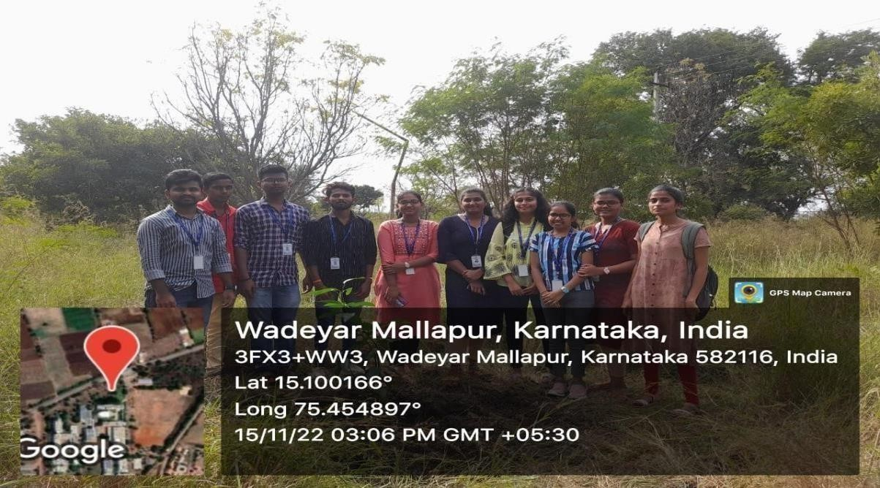

**Figure1.1: Plantation and Adoption of Tree**

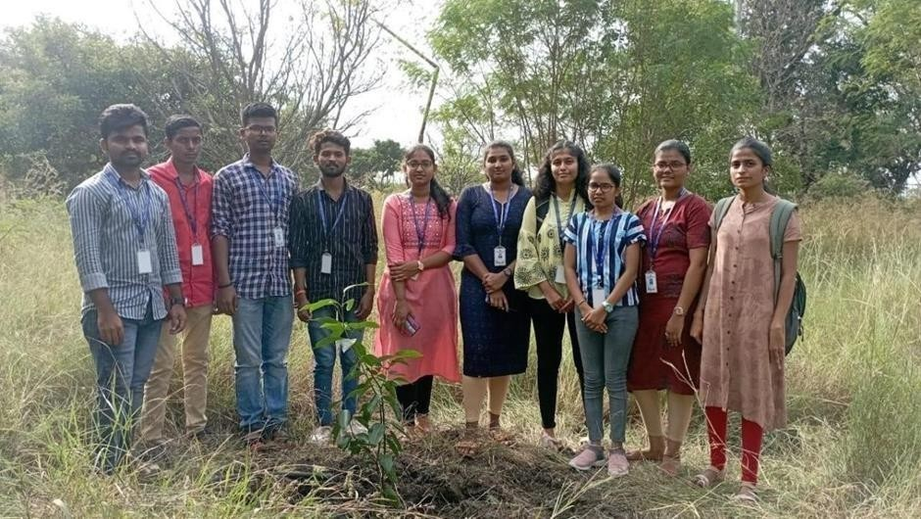

## Activity2: Heritage Walk and Crafts Corner

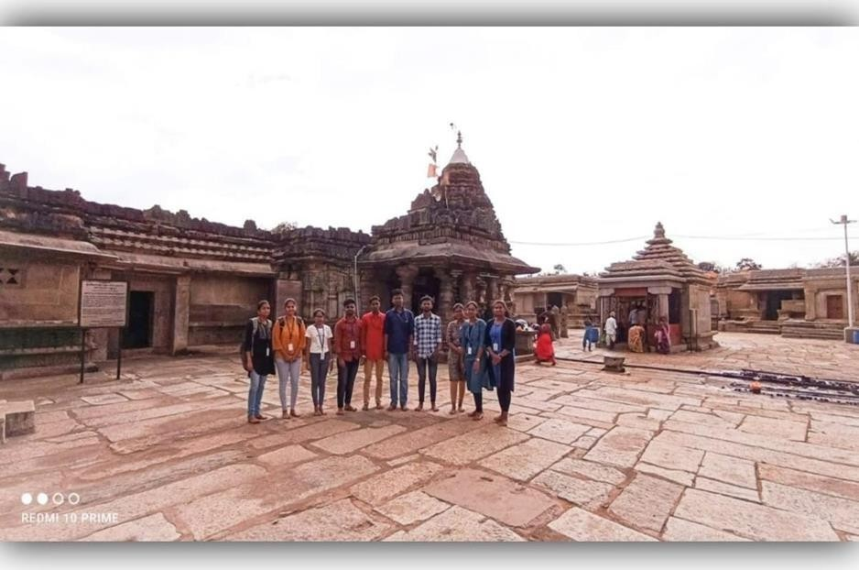

Fig 2.1 : **Heritage walk to Someshwara temple**



## Activity3: Organic Farming

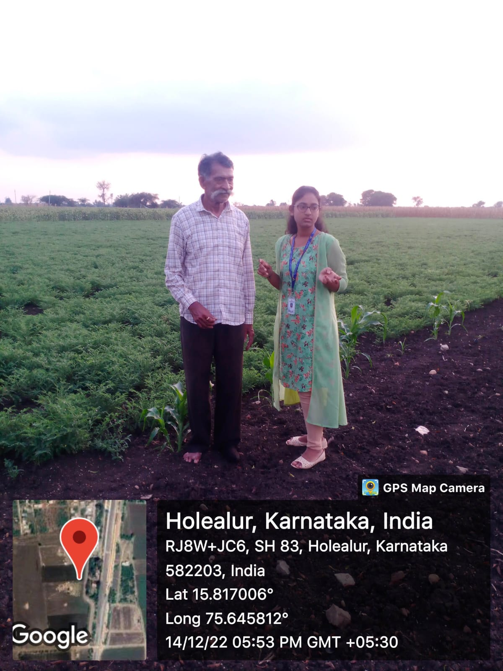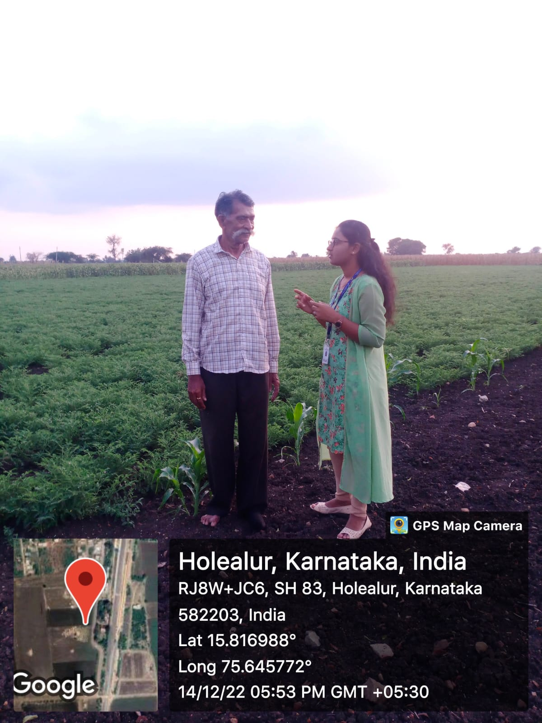

**Fig 3.1: Organic Farming at Lakshmeshwar.**

## Activity4: Waste Management

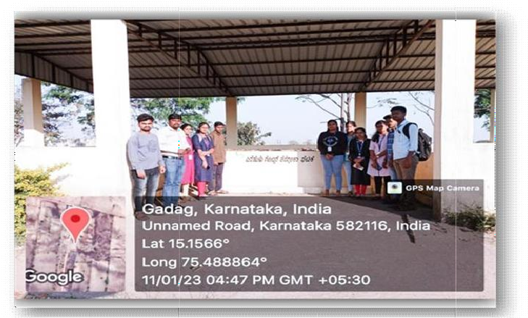

**Fig4.1: Waste Managment.**

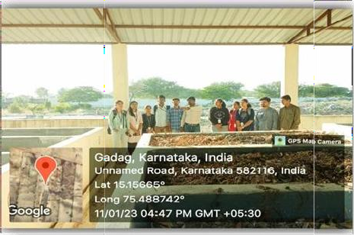

## Activity5: Water Conservation

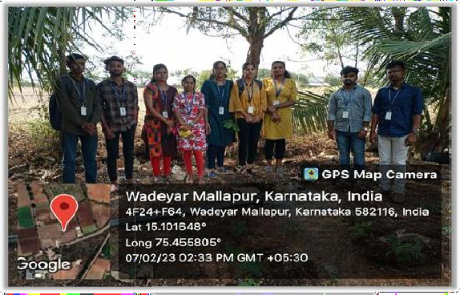

**Fig 5.1: Water Conservation.**

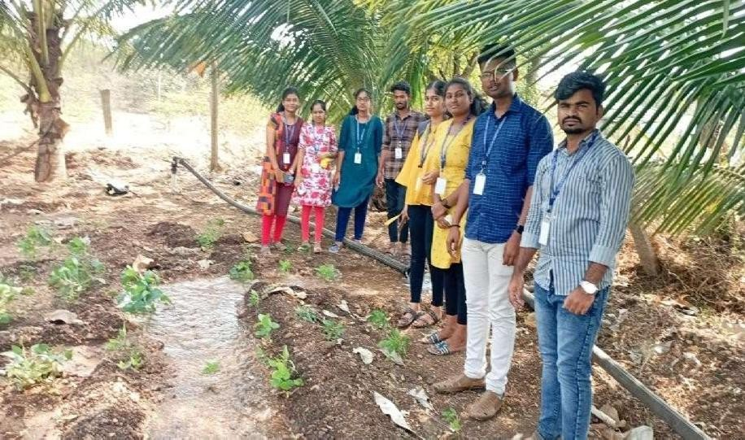

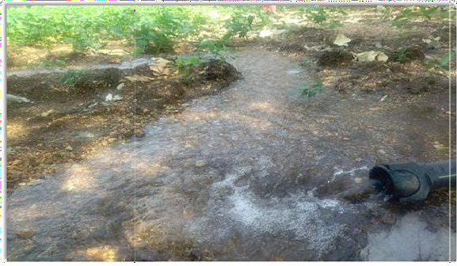

# CHAPTER5

### CONCLUSION

The five activities outlined above represent innovative approaches to promoting sustainable development and addressing key issues in rural areas. Each activity demonstrates how traditional knowledge can be integrated with modern technologies to improve lives while fostering eco-friendly practices.

#### Plantation And Adoption of Tree:

By incorporating these sustainable practices and leveraging technology, SKSVMACET in Lakshmeshwar can successfully adopt cinnamon cultivation while also promoting environmental sustainability, enhancing local agriculture, and providing valuable educational opportunities for students. The focus on sustainable water usage, soil health, pest management, and community involvement will ensure that the cinnamon plantation thrives while contributing positively to the local ecosystem and economy. Awareness programs, workshops, and environmental education campaigns help people understand the importance of trees in air purification, carbon sequestration, and mitigating climate change effects. Smart irrigation techniques, such as drip irrigation, rainwater harvesting, and IoT-based moisture monitoring systems, optimize water usage, ensuring efficient tree growth while conserving valuable water resources.

#### Heritage Walk and Crafts Corner :

By integrating these sustainable development practices, the heritage walk to Someshwar Temple can contribute to the preservation of the cultural and environmental integrity of the region, while also supporting local communities economically and socially. This holistic approach ensures that both heritage and the surrounding natural environment are protected for future generations to enjoy. Incorporating these technological innovations in the heritage walk to the Someshwar Temple can create an engaging, educational, and interactive experience for visitors. It will not only enhance the tourism experience but also contribute to the preservation of the temple’s cultural and historical value for future generations. By using technology to bridge the gap between the past and present, visitors can develop a deeper connection to the temple and its significance.

#### Organic Farming :

The best practices of sustainable organic farming aim to maintain the balance between food production, environmental health, and social equity. These practices not only contribute to ecological sustainability but also enhance farm profitability, foster community well-being, and help mitigate climate change. By adopting these methods, farmers can ensure that organic farming remains a viable and sustainable solution for future generations. By integrating these technologies, organic farming can become more productive, cost-effective, and sustainable, meeting the growing demand for organic produce while maintaining environmental stewardship.

#### Waste Management :

Through practices such as waste segregation at source, composting, recycling, waste-to-energy technologies, public awareness, and collaborations with the private sector, the municipality can manage its waste more efficiently and reduce its environmental footprint. By adopting these best practices, Lakshmeshwar can set an example of sustainable waste management, promoting a circular economy and a greener future for its residents. The use of technology in waste management has revolutionized how municipalities, like Lakshmeshwar, address waste disposal and recycling. As urban populations grow and waste generation increases, traditional waste management practices alone are often insufficient.

#### Water Conservation :

Technology is playing an increasingly important role in water conservation on agricultural fields, making it possible to use water more efficiently, reduce waste, and improve sustainability. From smart irrigation systems and soil moisture sensors to precision agriculture and drought-resistant crops, technological advancements are empowering farmers to manage their water resources more effectively. As global water resources become scarcer, these innovative technologies will continue to be vital in ensuring that agriculture remains productive while minimizing its environmental impact. By implementing sustainable development best practices in water conservation, farmers can improve water efficiency, minimize waste, and reduce environmental impact.

### REFERENCE

#### Plantation And Adoption Of Tree

1. Stephens, S. Sky; Wagner, Michael R. (2007). "Forest Plantations and Biodiversity: A Fresh Perspective". Journal of Forestry*.*
2. Dave Deppner; John Leary; Karin Vermilye; Steve McCrea (2005). The Global Cooling Answer Book (PDF) (Second ed.).
3. Toumey, J. W. and Korstian, C.F. 1942. Seeding and planting in the forestry practice. Ed. 3. John Wiley & Sons Inc., New York.
4. FAO Report on Global Forest Resources – [www.fao.org/forestry](http://www.fao.org/forestry)
5. IPCC Reports on Climate Change & Forests – [www.ipcc.ch](http://www.ipcc.ch/)

#### Heritage Walk and Crafts Corner

1. https://kalyangeetha.wordpress.com/tag/laxmeshwar/?utm_source=chatgpt.com
2. Kidan, E. (2007), 'Possibilities for developing coltormt tourism in the Municipality of Moscenick Bong the case of historical trails Tourism &- fospitality Management June 2007 VaF 13 210515-522
3. <http://www.parisiendunjour.com/>
4. <http://www.india-seminar.com/2003/530/530%20debashish%20nayak.htm>
5. <http://www.intach.org/living_heritagefestivals.htm>
6. <http://popularsikh.com/node/76206>
7. <http://www.bangalorewalks.com/exploriences.htm>

#### Organic Farming

* 1. https://[www.nordic-swan-ecolabel.org/nordic-ecolabelling/environmental-](http://www.nordic-swan-ecolabel.org/nordic-ecolabelling/environmental-) aspects/sustainable-raw-materials-biodiversity/organic-farming/references-organic-farming/
  2. Organic Farming - an overview: A chapter on organic farming in ScienceDirect Topics
  3. https://[www.cambridge.org/core/books/abs/organic-](http://www.cambridge.org/core/books/abs/organic-) farming/references/A07AAFD23C19F806EAA71980B39B0939#:~:text=%3EOrganic%20F arming,References

#### Waste Management

1. https://[www.oxfordreference.com/display/10.1093/oi/authority.20110803121220420#:~:text](http://www.oxfordreference.com/display/10.1093/oi/authority.20110803121220420#%3A~%3Atext)

=Quick%20Reference,or%20longer%20for%20many%20isotopes).

1. https://chescoplanning.org/uandi/ReducingWaste.cfm#:~:text=We%20can%20significantly

%20reduce%20the,and%20by%20using%20recycled%20materials.

1. Waste Analysis for Energy From Waste Plant Operators by MEL Research Limited (1998)
2. https://web- archive.southampton.ac.uk/[www.suewaste.soton.ac.uk/publication/KeyReferences-on-](http://www.suewaste.soton.ac.uk/publication/KeyReferences-on-) WasteDataManagement.pdf

#### Water Conservation

1. I. Shiklomanov. (1993) Water in Crisis: A Guide to the World’s Freshwater Resources. Oxford University Press, pp. 13.
2. Supply Concerns Continue, and Uncertainties Complicate Planning. (2014). U.S Government Accountability Office.
3. United States Environmental Protection Agency. (2016). WaterSense. www3.epa.gov/watersense/index.html
4. OECD Glossary of Statistical Terms - Water Conservation Definition." OECD Glossary of Statistical Terms - Water Conservation Definition. N.p., 25 Sept. 2001. Web. 12 May 2016.

<https://stats.oecd.org/glossary/detail.asp?ID=2903>.

1. <http://www.pumpfundamentals.com/pump_specialty.html>.